Progress report 91-2020
NRCS CCGA Woody Plant Control
NR186740XXXXG005
3F9333
Progress report 4/1/20 to 9/1/20
We have completed a second year of data collection regarding our eastern red cedar (ERC) management goals: 1) seed bank ecology, 2) ERC growth rates and spread, 3) tree moisture dynamics, and 4) survival by vegetation type and grazing intensity. We have also begun implementing the rancher defined projects: 1) cost benefit analysis, 2) soil nutrient analysis, 3) erosion, infiltration, and runoff, and 4) tree needle oil content dynamics. We collected a second set of data on sites at three ranches (Mulehead, Greg Schmitz, and the Grim Ranch) in Gregory County, SD and set up new plots on a ranch (Todd Olson) in Brule County. Two graduate students, Dr. Smart, and Dr. Xu collected data to address ERC objective #2, #3 and #4 and rancher-defined objectives #1, #2, and #3. The Mid-Missouri River Prescribed Burn Association (MMRPBA) was not able to conduct any prescribed burns due to COVID-19 in 2020. So, no acres have been submitted in 2020 for payment. The MMRPBA has completed a fourth newsletter (July 2020) and updated their website (https://www.midmissouririverpba.com/).
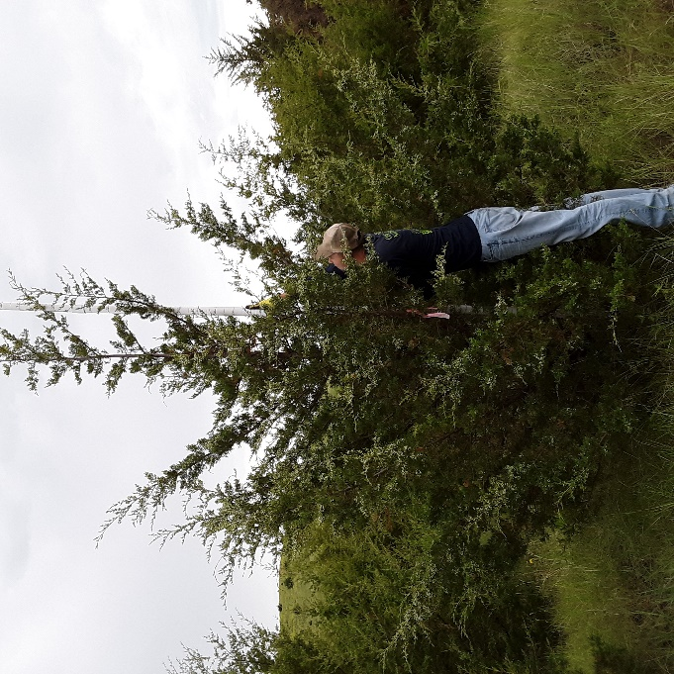
ERC growth rates. Our objectives were to evaluate how much cedar trees grow in height, canopy area, and tree trunk diameter. In June 2019, we permanently marked 30 cedar trees per ranch on three ranches north of Bonesteel, SD. We categorized trees into 5 height classes: <50 cm, 50-99 cm, 100-199 cm, 200-399 cm, and >400 cm tall. Each tree was tagged with a metal tag and we recorded its global position with a GPS unit. We measured the tree height to the nearest cm (Figure 1). Tree canopy diameter was measured along the longest axis and another perpendicular to it. We used the average diameter from the two measurements to calculate the circular canopy area. Finally, we measured the basal diameter of the tree trunk and the diameter breast height (4.5 ft high) of the trees that were tall enough. All the measurements were repeated on the same trees in June 2020. The trees we marked ranged from 16 cm (6 inches) to 1200 cm (38 ft) in height.
Figure 1. Robby Schaefer holding a PVC pole with measuring increments to estimate cedar tree height (Photo by A. Smart, June 2020)
For the tree height, the smallest cedar trees (class 1) grew the least and the trees in class 3 (100-199 cm) grew the most (Table 1). Growth in tree height from classes 2, 3, 4, and 5 were statistically similar to each other.
Table 1. Change in cedar tree height, canopy area, basal diameter, and diameter breast height from 2019 to 2020 by tree height class
Tree height class | Height  (cm) | Canopy area  (cm²) | Basal diameter (mm) | Diameter breast height (mm)
1 (<50 cm) | 8 | 40 | 2.2 | NA
2 (50-99 cm) | 25 | 487 | 7.8 | NA
3 (100-199 cm) | 32 | 725 | 13.6 | 6.1
4 (200-399 cm) | 31 | 446 | 21.5 | 12.6
5 (>400 cm) | 22 | 1743 | 23.6 | 20.4

Tree canopy area increased the least for the smallest tree class (<0.1 ft²) and the most for the largest tree class (almost 2 ft²) as you would expect. The tree classes 2, 3, and 4, growth rate was about 0.5 ft²/tree/year. Basal diameter and diameter breast height also increased in similar trend as tree canopy. For the largest tree class, trunk basal diameter and diameter breast height annual growth rates were 1 inch/yr and 0.75 inch/yr, respectively.
To put these growth factors into perspective, lets imagine a one acre pasture with 50 cedar trees (3-6 ft tall or class 2 & 3). If these trees grow its canopy area by 0.5 ft²/tree/year for a total of 25 ft²/year, they would fill up the pasture in 35 years. This estimate is based on the assumptions that no new recruitment will occur and tree canopy growth rate maintains a constant 0.5 ft²/tree/year. However, in reality, we know recruitment does occur and older trees have higher growth rate. Thus, the pasture fill-in by cedar trees would be much less than 35 years. We can obviously see why cedar trees are such a problem.
Finally, we were curious to find out how old eastern red cedar trees are at our sites and the relationship between tree age and height. In order to establish this relationship, we harvested 40 trees ranging in height (37-231 cm) from a USFWS Waterfowl Production Area north of Volga, SD in Brookings County this past spring. We recorded tree height, basal trunk diameter, diameter breast height, and canopy diameter in two perpendicular directions as described above. We brought tree trunk cross-sections back to the lab and sanded them with fine-grit sandpaper. We then counted the rings and measured the width of each of the outer five rings (2015-2019 growing years) under a dissecting microscope.
We found that trees around 50 cm (20 inches) are about 6 year-old (6 tree rings). This relationship was described by a natural log function (Figure 2) and the height growth rate decreases as the trees get taller. We also found that the width of the rings had a linear relationship with tree height (Figure 3). As trees get older/taller, they increase girth growth rate (i.e. basal tree trunk diameter). The oldest/tallest trees annual girth growth rate was about 6.3 mm (0.25 inch). This is about half the growth rate of the trees in Gregory County with 100-199 cm tall.
Figure 2. Relationship between eastern red cedar tree height and tree rings

Figure 3. Relationship between eastern red cedar tree height and ring growth rate

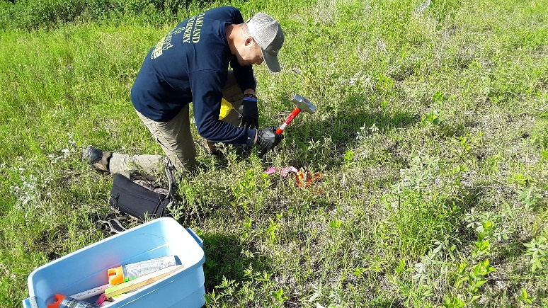
Cedar tree recruitment. Our objective was to measure recruitment of cedar trees in a known area. In June 2019, at each of the three ranches, we established 6 permanent 10 x 10 m plots (Figure 4). In each plot, we counted the number of cedar trees, GPS their locations, and measured their heights. In June 2020, we revisited each plot and recounted the number of trees and measured the height. Thus, we were able to tell if they were trees that survived from last season or were new seedlings that sprouted this year (new additions).
Figure 4. Robby Schaefer marking the corners of the 10 x 10 m eastern red cedar tree encroachment plots (Photo A. Smart, June 2019)
Change in cedar tree density per 10 x 10 m plot ranged from -0.67 to 4.5 trees per plot. Two out of the three ranches showed an increase while one ranch had decreased. If we took the average of all three ranches, it would be 2.5 new trees per 100 m²/year. That would be equivalent to 100 trees per acre. This is a high recruitment rate. A lot of the new trees we counted were less the 8 cm tall (3 inches or less). These trees may or may not survive depending upon the weather conditions, disease, or defoliation by animals or insects. And this is only one year’s worth of data. We intend to keep collecting data in these plots so we can get a better estimate. We noticed at one of the ranches (which had the highest encroachment rate) it had large female trees adjacent to the plots. We think that seed falling off these large trees are the most likely seed source. At the ranch where we saw a decrease in tree count, large female trees were much further away. Thus, we think birds or mammals are probably responsible for seed dispersal into these plots. Also, livestock use this site in the winter and could have bedded down and killed some of the smaller trees, which would have accounted for a net loss. We noticed a few trees not in our plots rubbed on by livestock. Livestock use the other sites during the summer.
ERC Tree moisture (or dry matter DM)
We tracked ERC tree dry matter (DM) once a month starting in February from trees between 1-2 m tall. As anticipated ERC tree DM was highest when the ground was frozen and decreased in DM as the growing season began (Fig. 5). We anticipate tree DM will increase in the fall and winter when the growing season comes to a close. This information will be used by the MMRPBA to assess whether they can burn in different times of the year (when tree DM is highest).

Fig. 5. Eastern red cedar tree branch/needle dry matter. Three branches from each of 10 trees 1-2 m tall were sampled once a month in 2020 near Volga, SD.

Eastern red cedar tree survival by vegetation type and grazing intensity
Eastern red cedar trees (seedlings) were transplanted in June 2019 into grass plots dominated by introduced cool-season grass vegetation or native warm-season grass vegetation. Half of the plots were trimmed to 4-6 inches once a week to simulate heavy grazing during the growing season and half of the plots were left untrimmed. In June 2020, we assessed tree survival of the 2019 transplants (Fig. 6).
Fig. 6. Eastern red cedar tree survival one year after transplanting. Treatments were grass community type (cool-season or warm-season) and clipping (4-6 inches once per week during the growing season or no-clipping).

ERC seedlings are shade intolerance, did not survive as well under warm-season perennial grass sod compared with cool-season perennial grass vegetation. Areas invaded by cool-season species, appear is more susceptible infestation by ERC from seedling establishment. Simulated grazing (clipping the grass weekly to a 4-6 inch stubble) had higher survival than no clipping.
A second set of transplants were planted in June 2020 and the same treatments were applied. We will evaluate survival in June 2021.
Soil samples
Soil samples were collected for a second year (2020) from cedar tree woodlands that were burned in 2017, 2018, and 2019, and from unburned cedar woodland and grassland controls. Soil nutrients N, P, and K; soil aggregate stability; soil OM; and soil microbial community were analyzed in the lab. We will summarize these data this fall/winter and write up reports from the graduate student’s thesis.
Water infiltration, runoff, and sediment
Water infiltration, runoff, and sediment was collected a second year from cedar tree woodlands that were burned in 2017, 2018, and 2019, and from unburned cedar woodland and grassland controls. A Cornell Sprinkler Infiltrometer was used to collect infiltration, runoff, and sediment estimates. We will summarize these data this fall/winter and write up reports from the graduate student’s thesis.
Video
Two workshops were held on March 3, Yankton, and March 5, Mitchell with about 32 and 33 attendees at each location, respectively. The workshop in Yankton was videotaped by SDSU and is available on Youtube at: https://www.youtube.com/playlist?list=PLlldDb7IZYqIc80uMFNOSlJwKcQN87XoM. The workshop is split into 6 video segments. The videos have had 200 views since June 9, 2020.
Newsletter
The summer 2020 newsletter was printed in July 2020. See attached pdf.

